change, grow, live (CGL
)

and

Community Pharmacies

SERVICE LEVEL AGREEMENT

Supervised Consumption Programme

February
1

201
9

-

31
January
202
0

Overview and service principles

1.1 Community Pharmacies play an important role in the care of substance misusers. They enable Service Users to comply with their prescribed regime by supervised consumption of Methadone, Buprenorphine, Espranor or Suboxone.

1.2 Opiate substitutes should be administered daily, under supervision, normally for the first three (3) months of treatment. Supervision will be relaxed when the Service User’s compliance and risk management has been assessed.

Aims and intended service outcomes

2.1 To reduce opportunity for diversion and illicit supply of controlled drugs, which may lead to a reduction of drug related deaths in the community.

2.2 To ensure client compliance with prescribed medication

Service outline

3.1 The Pharmacy will offer a user-friendly, non-judgmental, patient-centred and confidential service

3.2 The service will require the pharmacist to supervise the consumption of prescribed medications when indicated by the prescriber, ensuring that the dose has been administered appropriately to the Service User.

3.3 Wirral Ways to Recovery will contact the Service User’s chosen pharmacy prior to them attending the pharmacy, to ensure the pharmacy has capacity to take on a new Service User. The prescriber will provide the Pharmacy with the Service Users’ details.

3.4 The Service User’s key worker will be responsible for obtaining their agreement to supervised consumption.

3.5 The pharmacy will provide support and advice to the service users, including referral to other primary care services or health and social care professionals where appropriate.

3.6 The pharmacy will continue to provide advice and support to service users who are moving from supervised consumption to daily pick-up and beyond, this may include referral back to the prescriber where appropriate.

3.7 The Home Office has changed the approved wording on instalment prescriptions for Controlled Drugs. The pharmacist should be aware of the different wordings as listed below, and ensure they dispense in line with the approved wordings on the prescription. If the prescription does not reflect such wording, the regulations only permit the supply to be in accordance with the prescriber’s instalment direction:

- Please dispense instalments due on pharmacy closed days on a prior suitable day.

- If an instalment’s collection day has been missed, please still dispense the amount due for any remaining day(s) of that instalment.

- Supervise consumption on collection days.

- Dispense daily doses in separate containers.

3.8 The service is provided within a community pharmacy in an area maintained to a professional standard. The supervision will take place where possible in a consultation room which, as a minimum, should:

- Allow the client to take the medication out of public view;
- Be constructed such that the client cannot be easily overheard when talking to the pharmacist;
- Should not be used to store stock or act in the capacity of a staff room at any time.

  - If the medication is dispensed for non-supervised consumption (e.g. Sundays, bank holidays) the service user must be provided with information regarding the safe storage of the medication and reminded of the danger it presents to others.

  - Methadone: The pharmacy will present the medicine to the service user in a suitably labelled receptacle and will provide the service user with water to facilitate administration and/or reduce the risk of doses being held in the mouth. If a service user’s dose is measured out in advance of their visit then suitable containers with lids should be used. These shall be individually labelled as per normal labelling regulations. Prior to disposal of these containers, all identifying labels shall be removed/anonymised.

  - Buprenorphine, Espranor and Buprenorphine/Naloxone: The pharmacy will prepare the dose and place in a medication measure. The service user will be provided with water (in a disposable cup) prior to issuing the dose, this may speed up the process of the medication dissolving under the tongue. The medication should be tipped directly under the tongue without handling. The service user will need to be supervised until the tablet has dissolved. This may take up to 10 minutes. When most of the tablet is dissolved, and only a chalky residue remains, talk to the service user to determine the dose has fully dissolved. Offer a further drink of water.

Crushing of tablets is Off Licence and therefore should not be undertaken unless the prescriber requires this. If required the prescriber must write this on the prescription and both the prescriber and service user must be aware that this is Off Licence.

  - Pharmacists and staff involved in the provision of the service must be aware of and operate within any locally agreed protocols and follow their company Standard Operating Procedures that cover the provision of this service.

  - The service is delivered by an accredited pharmacist who is responsible for providing the services at the pharmacy in keeping with the published guidelines. If the accredited pharmacist permanently leaves the pharmacy in question, the new pharmacist should be trained as soon as is feasible.

  - Pharmacy staff must be aware of local child, and vulnerable adult, protection procedures. These must be followed at all times.

Data recording & Information Sharing

4.1 The pharmacy will maintain records of the service provided. All provisions will be recorded on PharmOutcomes. These records will be operated together with the Controlled Drug Records required by legislation.

4.2 WWTR will provide a framework for the recording of relevant service information for the purposes of audit and the claiming of payment, currently the web-based PharmOutcomes system.

4.3 On ALL occasions the service user fails to attend the pharmacy to collect a prescribed dose of medication, a record must be made and this information reported to the WWTR Prescribing Administration Team with 24 hours by completing the “Controlled Medication Missed Collection Form” (Appendix 1, page 9). Only one form is required per day, where all clients’ details that missed a dose the previous day will be recorded.

4.4 The form must be sent to the WWTR Prescribing Administration Team by either:

- Fax to: 0151 203 3111 or
- Email to: wirral.services@cgl.org.uk (N.B. Pharmacies are advised to use their NHS email account to email any patient identifiable information)

Please note, only the above two methods of communication provide a secure and guaranteed way of relaying this information to the prescriber.

  - Once a prescription is completed, the service called “Supervised Consumption – Supervision” will be completed on PharmOutcomes. If this is the first time the service user has presented at the pharmacy the service called “Supervised Consumption- Registration” will need to be completed as a one off activity before the supervision can be entered.

  - Any missed doses will need to be entered on a daily basis to the service called “Supervised Consumption – Missed dose” on PharmOutcomes. This will allow WWTR to keep an additional electronic record of when service users have not attended the pharmacy for their supervised medication.

  - Where the service user has not collected their medication for three consecutive days, the supply must be stopped and not be started again without the agreement of the prescriber.

  - The pharmacy providing the dispensing service will contact WWTR in any of the following circumstances (please see Appendix 2, page 10):

    - Drug related death in pharmacy premises
    - Overdose
    - Incorrect dispensing of any controlled substance
    - The service user is seen to be selling, swapping or giving away their controlled medication
    - Following three consecutive failures to attend. Where three consecutive doses have been missed, the pharmacist will not supply a further dose and the service user should be referred back to WWTR to be clinically re-assessed
    - Breach of the Service Agreement which the service user has signed
    - Any other occasion when the pharmacist is concerned about the service user’s well-being
    - Refuses to consume their dose as prescribed
    - Is collecting erratically (even if not breaching the 3-day rule)
    - Is under the influence of drugs/alcohol resulting in the pharmacist making a professional judgement decision not to dispense a dose
    - Shows clear signs of deterioration of physical and/or mental health
    - Has been violent or has threatened violence
    - Is involved in a serious or untoward incident that affects or may affect the expected outcome of the treatment

  - Pharmacists will share relevant information with other health care professionals and agencies, in line with locally determined confidentiality arrangements. The service user should be informed that information is being shared (unless to do so would put another person at risk e.g. in the case of suspected child safeguarding issue)

  - The information required to be reported on PharmOutcomes may be developed to reflect the changing requirements of the commissioner

Eligibility

5.1 The service is available to adults (aged 18 years or over) who are in receipt of prescribed substitute medication as part of an active treatment programme for substance misuse where:

- Prescribing is undertaken by a prescriber at a WWTR base or by a GP with Special Interest
(GPwSI) and GPs participating in formal Shared Care arrangements within the Wirral area.
- Supervised administration is specified by the prescriber;
- The individual is usually resident within the Wirral area.

Accessibility

6.1 Selection of the pharmacy to provide treatment will be the decision of the service users, subject to the nominated pharmacy agreeing to commence treatment.

6.2 Service users will in effect register with a participating pharmacy for the duration of their treatment. Pharmacists will be required to provide on-going support during a period of Supervised Administration Programme, which will normally be up to 3 months, or until the patient transfers to another pharmacy at the direction of the prescriber.

6.3 The contractor will ensure that there are no unreasonable or strict time restrictions imposed on the service user.

6.4 The pharmacist in charge will take appropriate steps to ensure they are confident of the identity of the service user before supervising each dose.

6.5 The pharmacist in charge will make an assessment that it is safe to supply the medication before supervising the dose.

Quality indicators

7.1 The contractor will ensure availability of written information and leaflets in the pharmacy relevant to the service, substance misuse and drug treatment as made available by WWTR.

7.2 The contractor will have standard operating procedures. The pharmacist will review these standard operating procedures and the referral pathways for the service at least every 2 years.

7.3 The pharmacy can demonstrate that pharmacists (including locums) and staff involved in the provision of the service will have sufficient knowledge of the service and are familiar with the requirements of this service specification.

7.4 The lead pharmacist must have successfully completed the CPPE declaration of competence which includes the course “Substance Use and Misuse” (Pharmacist Version) and Safeguarding Children and Vulnerable adults. The completion certificate for these courses must be no more than three years old.

7.5 The pharmacy undertakes the supervision in an area that ensures a sufficient level of privacy and safety.

7.6 The pharmacy will participate and co-operate in any WWTR organised audit of the service provision or assessment of Service User experience.

7.7 The contractor should ensure that there is adequate support staff, including staff specifically trained to support this service in the pharmacy at all times in order to support the pharmacist (including locum pharmacist) in the operational elements of the service and to help ensure the safe and smooth running of the service.

7.8 The contractor will ensure that appropriate professional indemnity insurance is in place.

7.9 It is a requirement for pharmacies signing up to this agreement to comply with all the requirements of the essential services of the NHS Community Pharmacy Contractual Framework.

Reportable Incidents & Complaints

8.1 Reportable incidents (including dispensing errors and suspected breaches of the Controlled Drugs Regulations 2013) will be reported in line with national guidelines. The pharmacy will provide a copy of the incident form to the contracts manager.

8.2 The pharmacy will deal with any complaints sensitively and will report any complaints, comments or concerns to the WWTR Contract Manager within 2 working days.

Skills and Competency Framework

9.1 The service provider will ensure that all practitioners and staff engaged in the delivery of this
service are competent to do so. As a minimum, practitioners and staff will:

- adhere to the standards and practice guidance set by the RPS for the provision of services to drug misusers and needle exchange services in community pharmacies detailed in “Medicines, ethics and practice: a guide for pharmacists” (RPS, latest edition).
- evidence the competencies as detailed in the Drug & Alcohol National Occupational Standards (DANOS)

For further information on the application of DANOS standards see: http://www.fdap.org.uk/documents/Vision%20thing%20practitioners%20&%20managers.pdf

Required Training

10.1 All pharmacists will be required to complete the CPPE Declaration of Competence for Supervised
Administration of prescribed medication, the CPPE Substance use and misuse (2nd edition) and CPPE Safeguarding Children and Vulnerable adults. It is recommended that all registered pharmacy technicians complete the same declaration.

10.2 WWTR will arrange at least one contractor interaction per year to promote service development and update the knowledge of the accredited pharmacist.

10.3 Practitioners and staff must meet these minimum requirements within three months of joining the service.

Use of Locum Pharmacists

11.1 The contractor has a duty to ensure that staff and other pharmacists (including locums) involved in the provision of the service have relevant knowledge and are appropriately trained in the operation of the service to ensure the smooth continuation of the service in their absence

11.2 Where possible, the contractor should ensure that the pharmacy is staffed by a regular pharmacist/s. Should a participating pharmacy be in a position where a different locum pharmacist(s) dispenses for more than a month, the Contract Manager must be informed.

11.3 The contractor should ensure that there are adequate support staff, including staff specifically trained to support this service in the pharmacy at all times in order to support the pharmacist (including locum pharmacist) in the operational elements of the service and to help ensure the safe and smooth running of the service.

11.4 The contractor will ensure that appropriate professional indemnity insurance is in place for any locum.

Payment arrangements

Service Provided | Fee
Supervised Consumption – Supervision Espranor | £1.60 per dose
Supervised Consumption - Supervision Methadone | £1.60 per dose
Supervised Consumption- Supervision Subutex (Buprenorphine) | £1.92 per dose
Supervised Consumption – Supervision Suboxone | £1.92 per dose

12.1 Payments will be made monthly upon input of the data onto PharmOutcomes. Invoices will be generate automatically by PharmOutcomes on the 5th of the month.

12.2 Fees will be paid on the basis of submitted claims. Please note the WWTR preferred method of payment is BACS and this can be easily set-up by sending the Contracts Manager details of the bank account and sort code number on official pharmacy letter headed paper.

12.3 Contractors are responsible for entering accurate claims data onto PharmOutcomes. This must be done by no later than the end of the following month following the provision date. Please note PharmOutcomes has been configured to reject claims older than this timeframe.

12.4 Use of the service will be reviewed on a regular basis and the service may be redeployed to an alternative location by WWTR if uptake of the service is low.

12.5 Either party wishing to terminate this agreement must give one month’s notice in writing. However, WWTR reserves the right to suspend or terminate the service at short notice following a significant event or serious incident (for example, following a fitness to practice incident).

Termination

13.1 Use of the service will be reviewed on a regular basis and the service may be redeployed to
an alternative location by WWTR if uptake of the service is low.

13.2 This agreement may be terminated if either the pharmacy or WWTR give the other party one month’s
notice in writing during the duration of the contract.

13.3 If the pharmacy or WWTR is in breach of the agreement, the agreement can be terminated with one
month notice in writing or with immediate effect for a serious breach or incident (e.g. following a fitness to practice incident).

Governance

14.1 It is implicit in the service being provided that it is delivered to the standard specified, and complies with the legal and ethical boundaries of the profession.

14.2 Should an issue be identified either through a visit or through any other means an action plan will be produced following the process below:

- WWTR representative will identify any issues and will agree with the named pharmacist and an action plan will be created.
- The Contract Manager will send a written report to the named pharmacist within two weeks of the visit summarising what action needs to be taken and by when.
- The Contract Manager will contact the pharmacy again once the agreed timescales have elapsed to confirm that the action plans has been completed.
- If any further action needs to be taken, this will be documented and new timescales agreed.
- If the issues remain unresolved after this, the option to withdraw the service from the pharmacy may be exercised
- Please note that the pace with which the process progresses will be determined by the level of risk. In addition, any serious professional matters identified may be escalated to Public Health England or GPhC.

Signed for and on behalf of CGL
Signature: | Helen Richards
Name: | Helen Richards
Position: | Contracts and Compliance Manager
Date: | 17/01/2019
Signed for and on behalf of Contractor
Signature:
Name:
Position:
Date:
CONTRACT MANAGER
CGL Role/Responsibility | Contract/PharmOutcomes/Invoices/Incidents
Name: | Helen Richards
Office address: | 23 Conway Street, Birkenhead, Wirral, CH41 6PT
Tel No: | 0151 556 1335 or
E-mail Address: | helen.richards@cgl.org.uk

Please list contractor branches (for multiple sites)

Controlled Medication Missed Collection Form

Pharmacy: _______________________________ Date: ____________________
CLIENT NAME | DOB | DAY MISSED (insert date)

Please send this form to the Prescribing Administration Team at Wirral Ways to Recovery on either:
- Fax: 0151 203 3111 or
- Email: wirral.services@cgl.org.uk (N.B. Pharmacies are advised to use their NHS email account to email any patient identifiable information)

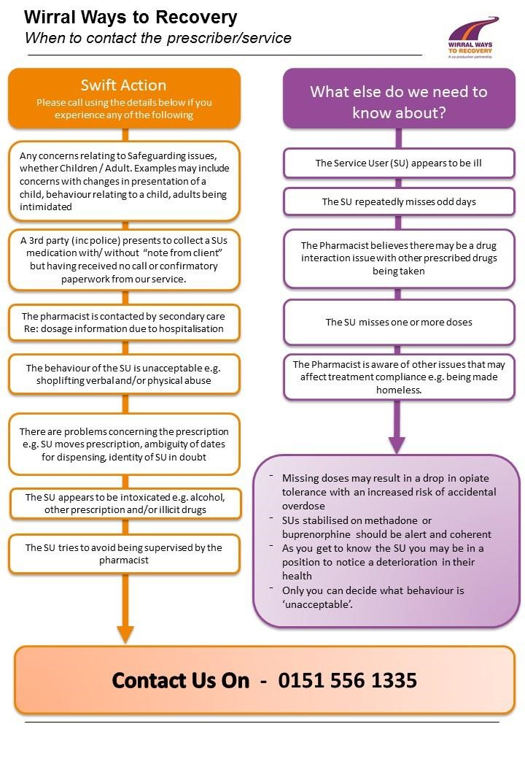
Page

