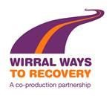

Provision of Alcohol Identification and Brief Advice Support and Guidance

Service Level Agreement

Parties to the Agreement | Provider:
1 February 2019 - 31 January 2020 | Wirral Ways to Recovery (WWTR), CGL

1. Background

Excessive drinking is a major cause of disease and injury, accounting worldwide for 9.2% of disability adjusted life years with only tobacco smoking and high blood pressure as higher risk factors. For the NHS alone, the estimated financial burden of alcohol abuse is around £2.7billion including hospital admissions and attendance at A&E and primary care (The cost of alcohol harm to the NHS in England, DH, 2008). Health inequalities are clearly evident as a result of alcohol-related harm where Department of Health analysis of ONS data indicates that alcohol-related death rates are about 45% higher in areas of high deprivation.

The number of adults with an alcohol use disorder (drinking above the recommended levels) in Wirral is estimated to be more 74,000; 22.3% of these are currently experiencing harm from their drinking.

There is evidence of the effectiveness of community pharmacy-based public health interventions such as smoking cessation and methadone maintenance for addictions, and in the management of osteoporosis, diabetes and raised cholesterol. Service users report positive experiences of using community pharmacy-based public health services, suggesting these services are acceptable as well as effective. Wirral is generally very well served by community pharmacies. There is currently one pharmacy for every 3,402 residents, which compares extremely favourably to the national average of one pharmacy for every 5,000 resident population. With a rate of 29 per 100,000 population, Wirral also has a higher ratio of pharmacies than its geographical neighbours including West Cheshire (at 24 per 100,000), Warrington (at 22 per 100,000), and Knowsley (at 25 per 100,000). This is very encouraging in enhancing the spread of pharmacy screening for alcohol use.

Pharmacies delivering opportunistic advice, brief interventions for alcohol will make a positive and significant contribution to early intervention and prevention for people drinking at increasing risk and harmful levels. Furthermore there is a very large body of international research evidence that shows early identification of alcohol misuse and the delivery of brief advice can be very effective in reducing people’s drinking to lower risk levels. The evidence indicates that for every 8 people who receive advice, one will reduce their drinking to within lower risk levels. This compares favourably with smoking advice where one in 20 will change their behaviour on the advice given (Safe. Sensible. Social. The next steps in the National Alcohol Strategy, DH, 2007).

2. The service

The Pharmacy will be contracted to deliver a coordinated alcohol identification and brief advice as part of Wirral’s Alcohol Harm Reduction Strategy.

The identification, initial screening and completion of the AUDIT questionnaire may take place at the counter. The provision of brief advice and referral to WWTR (for specialist alcohol treatment) will be provided in the pharmacy consultation room.

3. Aims and intended service outcomes

- To support the reduction in the level of alcohol related harm within the community

- To provide advice to patients drinking at increasing risk levels

- To increase the number of referrals to WWTR service of those patients that have been identified as being at risk from their alcohol use

- To support Wirral Public Health to increase awareness within the local population to the associated health risks linked to alcohol use

- Service Description

4.1 To provide an Identification and Brief Advice (IBA) service through community pharmacies that has the following seven elements:

4.1.1 Identification
Using defined criteria (shown below), patients ‘walking into’ a participating Pharmacy will be offered screening using the AUDIT alcohol assessment tool (Alcohol Usage Disorder Identification Test, WHO 1982, Appendix IV).

Defined Criteria for Screening:
✓ Any patient aged over 18 that the Pharmacist / trained staff member identifies as needing advice/support around alcohol use

Patients presenting frequently with symptoms which may be associated with alcohol misuse such as:
- Gastric problems – e.g. peptic & duodenal ulcers
- Falls and associated injuries
- High blood pressure
- Diabetes
- Depression /Anxiety / Stress
- Pregnant women
- Homeless
- Identified during a Medication Use Review (MUR) or other services provided by the Pharmacy such as Smoking Cessation Consultations or CVD screening  

4.1.2 Screening using AUDIT-C

The Pharmacist/trained staff member will initially undertake an AUDIT-C (AUDIT Consumption) questionnaire (Appendix 1) with the patient. This will indicate whether an individual is potentially drinking at increasing or higher risk levels, but does not indicate alcohol dependence.

- For patients scoring 0 – 4: congratulate the patient on the benefits of lower risk drinking. No further action is required apart from recording/capturing this information on PharmOutcomes and to screen again in 12 months
- For patients scoring 5 or more, the pharmacist/trained staff member will continue and complete the remaining seven questions of the full AUDIT, to obtain a total final AUDIT score (Appendix 2)

4.1.3 Lower Risk

If a patient’s total final AUDIT score remains below 7 (lower risk category), congratulate the patient on the benefits of lower risk drinking. No further action is required apart from recording/capturing this information on PharmOutcomes and to screen again in 12 months

4.1.4 Brief Intervention

If a patient’s total final AUDIT score lies within 8-15 (increasing risk category), a brief advice/intervention should be carried out using the 2-sided Brief Advice Tool (also known as Structured Advice Tool, see Appendix 3) and which will cover:

- Explanation of recommended daily amounts
- What a unit of alcohol is
- Explanation of category of drinker
- Explanation of the content of the supporting leaflet

4.1.5 Referral

If a patient’s total final AUDIT score is above 16 (high risk drinking category) then with patient consent, an automated referral is made to WWTR for a comprehensive assessment. Both the referral form and patient consent are completed/captured on PharmOutcomes.

However, should a patient not give their consent for the referral, a Brief Intervention should take place (as described in 4.1.4) and the WWTR service leaflet should also be handed out. This may encourage patients to self-refer at a later date.

Patients can self-refer by attending the WWTR service (no appointment required) offered at the following Hubs:

- 23 Conway Street, Birkenhead, CH41 6PT Tel: 0151 556 1335 Option 1
- Ashton House, Chadwick Street, Moreton, CH46 7TE Tel: 0151 556 1335 Option 3
- Sunlight Group Practice, Sefton Road, New Ferry, CH62 5HS Tel: 0151 556 1335 Option 4
- 151-153 Brighton Street, Wallasey, CH44 2DU Tel: 0151 556 1335 Option 5

4.1.6 Screening using the Alcohol Quiz

The Pharmacist/trained staff member can complete an Alcohol Quiz questionnaire (Appendix 7) with the patient. Completion of the full quiz is required in order to obtain the patient’s full AUDIT score. Using the full AUDIT score the pharmacist/trained staff member can provide the following interventions:

- For patients with an AUDIT score: 0 – 7 (Low Risk)
      - congratulate the patient on the benefits of lower risk drinking
      - No further action is required apart from recording/capturing this information on PharmOutcomes and to screen again in 12 months

- For patients with an AUDIT score: 8 – 15 (increasing risk category)
      - a brief advice/intervention should be carried out using the 2-sided Brief Advice Tool (also known as Structured Advice Tool, see Appendix 3)
      - Explanation of recommended daily amounts
      - What a unit of alcohol is
      - Explanation of category of drinker
      - Explanation of the content of the supporting leaflet

- For patients with an AUDIT score: 16+ (high risk drinking category)
✓ with patient consent, an automated referral is made to WWTR for a comprehensive assessment

4.1.7 Monitoring of the service Pharmacies are expected to:

      - Use screening and data collection tools. The AUDIT-C, full AUDIT & Brief Advice Tool can be downloaded and printed from the following website: http://www.alcohollearningcentre.org.uk/
      - Alternatively, pharmacies may use the Alcohol Quiz. Pre-printed copies will be provided by WWTR and pharmacies are required to maintain adequate stocks by requesting replenishment in time. (See Appendix 7)
      - There is no restriction in patients completing the AUDIT more than once per annum. However, it is expected that staff involved in the provision of this service exercise some form of “patient selection/filter” to the best of their knowledge to avoid the unnecessary completion of multiple AUDITs on the same patients within short periods of time. WWTR will monitor and report back to the contractor (if necessary) on a monthly basis on patterns of AUDIT completions.
      - Record details about all AUDIT’s completed, brief interventions and referrals on PharmOutcomes

  - The Pharmacy has a duty to ensure that all staff involved in the provision of the service have relevant knowledge and are appropriately trained in the operation of the service. WWTR will also provide annual update sessions if required.

  - The Pharmacy has a duty to ensure that all staff involved in the provision of the service are aware of and operate within local protocols.

  - The Pharmacy should maintain appropriate records to ensure effective ongoing service delivery and audit.

  - WWTR will provide a framework for the recording of relevant service information for the purposes of audit and payment using PharmOutcomes

  - All pharmacy staff delivering the service must have:
Completed the Alcohol IBA e-learning course available from the Alcohol Learning Centre or attended a Public Health training event within the previous 2 years. The e-learning course can be accessed at: https://www.alcohollearningcentre.org.uk/eLearning/IBA/alcohol-iba-incommunity-pharmacy/ ii. The responsibility for the service including training and managing staff according to the approved protocol is with the pharmacy contractor. Staff should update their training every 2 years and the pharmacy should maintain training records which will be available for inspection if required by WWTR.

5. Quality Indicators

5.1 Annual training event(s) or additional refresher sessions for delivery of the service will
be arranged by WWTR depending on need or for new pharmacies delivering the AUDIT
service for the very first time

5.2 The Pharmacy must adhere to their company standard operating procedure written in line with the National Guidelines for the delivery of Alcohol Identification & Brief Advice (IBA)

5.3 The Pharmacy must participate and co-operate in any WWTR organised audit of the
service provision or assessment of Service User experience.

6. Duties of the Pharmacy

6.1. To input all records of patient AUDITs and advice given onto PharmOutcomes within the timescales identified in Appendix 5.

7. Duties of Wirral Ways to Recovery (WWTR)

7.1 To arrange annual event(s) for pharmacists/staff for the service, this may also include training and up skilling/refresher sessions

7.2 To provide information on how to access resources and service documentation including:
- WWTR Service leaflets 
- Alcohol awareness posters 
- Alcohol Quiz questionnaire  
 
7.3 To pay the Pharmacy monthly based on information/invoices entered onto the
PharmOutcomes system

8. Complaints

8.1 The provider must record any significant events or patient complaints. Any complaint
relating to this service must be reported by email to helen.richards@cgl.org.uk within two
working days.

9. Terms and Fees

9.1 The Pharmacy will be paid a fee for patients that take part in the service (See
Appendix 5 for precise payment rates)

9.2 To qualify for payment the following service must be provided:
- Support all patients to complete either the Alcohol Quiz or the AUDIT-C screening and full AUDIT questionnaire (where applicable) including initial
registration
- Congratulate patients scoring 0–7
- Provide a brief advice/intervention by a trained member of staff to all patients scoring
between 8-15
- Offer a referral to WWTR Service for Alcohol specialist treatment for patients with a
score of 16 or above
- Enter all data onto the PharmOutcomes database
 
9.3 A summary of the fees payable and conditions for payment are listed below:

    - Patients with an initial AUDIT-C score of 0-4 attract a fee and require initial registration and capture of the AUDIT score onto PharmOutcomes
    - For patients with a final total AUDIT score of 5-7 the fee will be paid upon initial registration and capture of full AUDIT questionnaire onto PharmOutcomes
    - For patients with a final total AUDIT score of 8-15 the fee will be paid upon initial registration and capture of full AUDIT questionnaire and Brief Intervention outcomes onto PharmOutcomes
    - For patients with a final total AUDIT score of 16 plus, the fee will be paid upon initial registration and capture of full AUDIT questionnaire and referral form
(with patient consent) to WWTR onto PharmOutcomes
  - Payments will be made by BACS direct into the pharmacy’s bank account, if this facility has not been set-up, payment will be made by cheque.

  - This service is subject to the usual Post Payment Verification (PPV) Procedures

  - Payment will only apply to those patients where data has been correctly entered and has been accepted for inclusion in service audit.

10. Variations to Terms

10.1 A request for variation may come from WWTR or the Pharmacy and should be made
in writing 30 days in advance of the date from which it is proposed the variation will
become effective.

11. Confidentiality and Data Protection

11.1 Information that can identify individual patients must not be disclosed without the explicit
consent of the patient.

11.2 The pharmacy must protect personal data in accordance with the provisions and
principles of the Data Protection Act 1998 and must ensure the reliability of their staff
that have access to the data.

12. Indemnity

12.1 The pharmacy should ensure that it is adequately covered with indemnity insurance for
the activities undertaken in this service.

13. Tax Liabilities

13.1 WWTR declare that it is the intention of the parties that the pharmacy shall have the
status of a self-employed person and shall be responsible for all VAT, Income Tax liabilities
and National Insurance or similar contributions in respect of fees.

14. Termination

14.1 This agreement may be terminated if either the pharmacy or WWTR give the other party
one month’s notice in writing during the duration of the contract.

14.2 If the pharmacy or WWTR is in breach of the agreement, the agreement can be
terminated with one month notice in writing or with immediate effect for a serious breach.

CONTRACT AGREEMENT AND SIGNATORIES

This agreement will run from 1 February 2019 to 31 January 2020

AGREEMENT:

Pharmacy Name: …………………………………………… (provider)

Address ……………………………………………

……………………………………………

……………………………………………

Signed: …………………………………….. Date: ……………...

(Pharmacist in charge)
Name (print) ……………………………………… Tel: …….………...

Please list branches if multiple sites:

Authorised by:

Date: | Who | Signed
Helen Richards
Contracts and Compliance Manager
Wirral Ways to Recovery

Andrew Cass
Services Manager
Wirral Ways to Recovery

Appendix 1: AUDIT-C Questionnaire

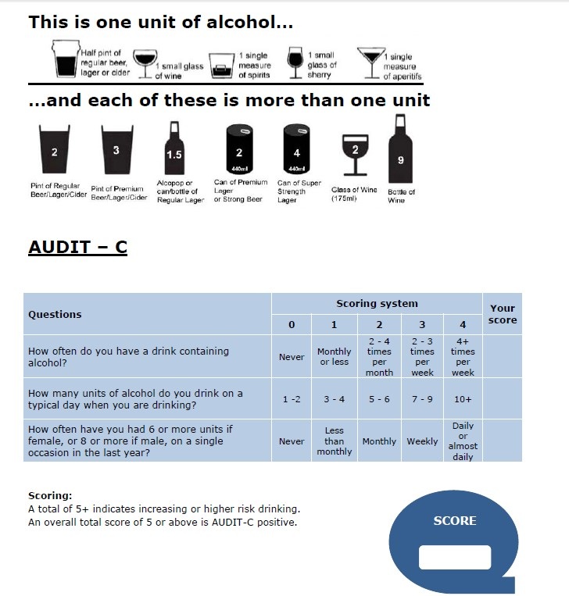

| P a g e

Appendix 2: Full AUDIT Questionnaire (remaining seven questions)
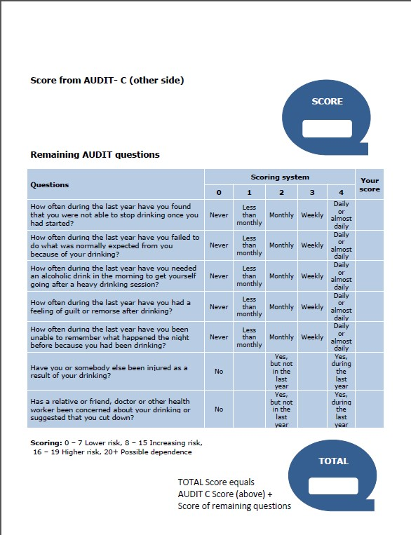

Appendix 3: Brief Advice Tool
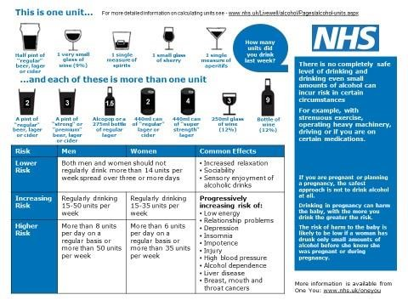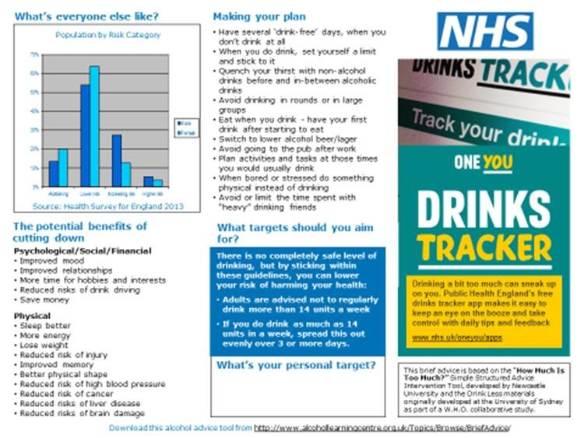

Appendix 4: Categorisation of alcohol misusers and pathway (Source: MoCAM 2005 &

Ready Reckoner 2011)

Category | Description
Increasing Risk Drinkers | Those with no apparent problems but taking risks with their longer term health through regular excessive drinking or intermittent sessions of heavy drinking
Higher Risk Drinkers | Those who are already experiencing physical.  psychological ill effects from their drinking but are not severely dependent
Dependent Drinkers | Those who have a wide range of alcohol related problems. Some are drinkers with complex problems such as co-existing physical or mental health needs, polydrug dependence and social problems
Binge Drinkers | Those who consume over double the maximum PHE recommended daily maximum number of alcohol units in one session.

Appendix 5: Rates & deadline dates for payment

The pharmacy will be paid a fee for each patient that takes part in the service. This fee is dependent on the AUDIT score of the patient and will be paid as follows:

AUDIT SCORE | TYPE OF DRINKER | SUPPORT PROVIDED | FEE PER PERSON
0-4 | Low Risk | AUDIT-C screening.  No further action required | £4 +VAT
5-7 | Low Risk | Full AUDIT screening. Feedback to patient that they are drinking at low risk levels | £4 +VAT
8-15 | Increasing Risk | Full AUDIT screening & Brief  Intervention | £7 + VAT
16+ | Higher Risk | Full AUDIT screening & feedback that patient is drinking at high risk levels. Referral to WWTR for Comprehensive Assessment | £7 + VAT

Payments only apply to ONE intervention in each ‘support provided’ section – there is no requirement to undertake more than one intervention per patient

Payment for participating pharmacies will be made monthly, retrospectively on submission of monthly monitoring data. In order to qualify for payment, complete patient AUDIT records must be submitted (onto the PharmOutcomes database) in line with the following timescales:

➢ Monthly deadline of the 5th for the previous month’s completed AUDITs

| P a g e

Appendix 6: Service Overview

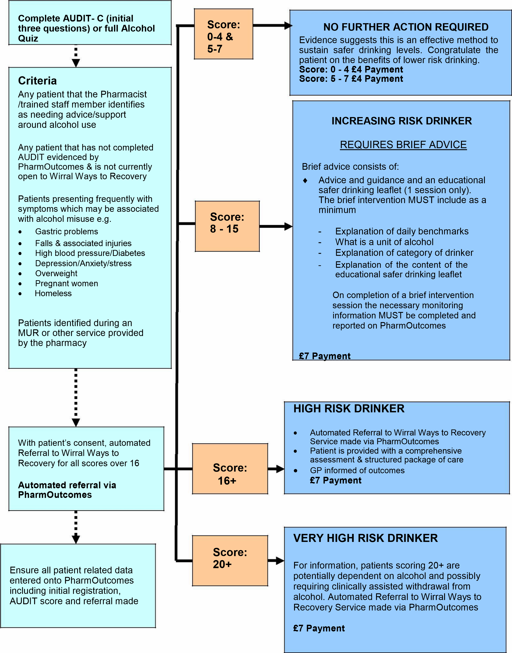

Appendix 7: Alcohol Quiz
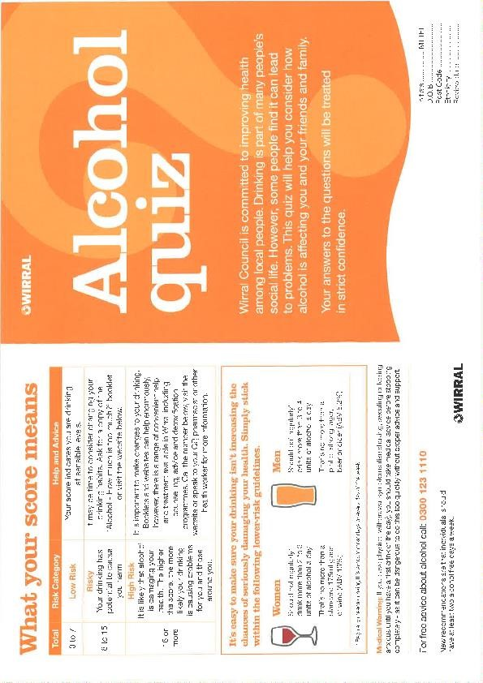

15 | P a g e

