 |  |  |  | Wirral Council
STRATEGIC HUB
COMMISSIONING SUPPORT
 |  |  |  | PO Box 290
 |  |  |  | Brighton Street
 |  |  |  | Wallasey
 | The Pharmacy Manager |  |  | CH27 9FQ
 |  |  |  | www.wirral.gov.uk
 |  | Date: |  | 14 March 2018
Your Ref:
Our Ref: | AM/ALLCHEM/2018/2020
Service: | Commissioning Support | Tel No: | 0151 606 2517

Dear Sir/Madam

PHARMACY SHARPS COLLECTION SERVICE 2018-2021

I am writing to invite your pharmacy to renew its participation in the Sharps Collection Service for the period 1st April 2018 to 31 March 2020.

The Sharps Collection Service has been operating in Wirral for a number of years to provide a means for members of the public to safely dispose of their medical sharps. Wirral Council will pay Service Providers £200 (excl.VAT) per annum to provide the service.

Your continued support in providing this important facility is valued, and I enclose a Service Level Agreement (SLA) for your attention.

Please note that the Pharmacy Sharps Collection service is entirely separate from the Wirral Ways to Recovery needle exchange scheme. Any sharps received by you as part of that scheme must continue to be collected separately, in agreement with that commissioner.

In order to participate in the scheme for this two year period, please provide the relevant details requested at the beginning of the SLA, contact details on page 15 and sign and return it to the address above FAO Mrs D Bradbury or by email to dianabradbury@wirral.gov.uk.

Together with your signed SLA we also require:
- Certificates of insurance for public liability cover and employment liability cover
- An invoice made out to Wirral Council for £200 (exc.VAT). Full bank details will be required on the invoice for payment to be made by BACS.

All paperwork should be returned by Wednesday 18th April 2018 at the latest to ensure that service provision is in place for the new contract period.

Any questions regarding the pharmaceutical aspect of this service should be directed to Melanie Carrol at Community Pharmacy Cheshire and Wirral - melanie.cpcw@gmail.com

For advice and guidance on ad-hoc pharmaceutical collections please contact NHS England at England.cmpharmacy@nhs.net

Yours faithfully
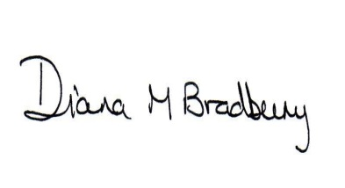
DIANA BRADBURY, COMMERCIAL LEAD
COMMISSIONING SUPPORT

