SCHEDULE 2 – THE SERVICES

- Service Specifications

Mandatory headings 1 – 4: mandatory but detail for local determination and agreement
Optional headings 5-7: optional to use, detail for local determination and agreement.

Service Specification No. | 1
Service | Palliative Care Emergency Medicines Service
Commissioner Lead | Barbara Dunton – Senior Commissioining Lead Primary Care
Provider Lead | Selected Community Pharmacies in Wirral CCG
Period | 1st April 2017 onwards
Date of Review | Review March 2019  Review required every two years or as required

1. Population Needs
  - National/local context and evidence base

This Service Specification defines the terms and standards required by the commissioners “Wirral CCG” for the provision of the Palliative Care Emergency Medicines Service under which the commissioned Service Provider (the community pharmacy contractor) and the accredited community pharmacist will provide a Palliative Care Emergency Medicines Service in line with the requirements of this service specification to patients in Wirral.

This service specification defines the terms under which the Community Pharmacy will hold a range and quantity of palliative care medicines and provide a Palliative Care Emergency Medicines Service for patients, carers and health professionals in Wirral CCG who have an immediate / urgent need for palliative care medicines.
The purpose of this service is to improve access to essential palliative care medicines, to ensure continuity of supply, and to support patients, carers and healthcare professionals by providing them with information, advice and signposting, where appropriate.

2. Outcomes
2.1 NHS Outcomes Framework Domains & Indicators

Domain 1 | Preventing people from dying prematurely | √
Domain 2 | Enhancing quality of life for people with long-term conditions | √
Domain 3 | Helping people to recover from episodes of ill-health or following injury
Domain 4 | Ensuring people have a positive experience of care | √
Domain 5 | Treating and caring for people in safe environment and protecting them from avoidable harm | √

2.2 Local defined outcomes

To improve access in Wirral CCG for patients and healthcare professionals to palliative care medicines when they are required within normal pharmacy opening hours.

To guarantee continuous availability of emergency palliative care stock from named pharmacies for patients and health care professionals who require immediate / urgent access to palliative care medicines.

To support patients in the palliative stage, carers and healthcare professionals with access to emergency palliative care medicines.

3. Scope
3.1 Aims and objectives of service

To provide immediate and consistent access in Wirral for patients and healthcare professionals to palliative care medicines when they are required within contracted pharmacy opening hours.

To guarantee continuous availability of stock on the palliative care emergency medicines list from named pharmacies for patients, patient representatives and healthcare professionals who require immediate / urgent access to palliative care medicines.

3.2 Service description/care pathway

The community pharmacy (from now on known as the service provider) will operate and provide the service strictly in accordance with this service specification.
A list of participating service providers can be found at Appendix 1.
The service specification will be subject to review every two years, unless there is a significant change in practice in this interval which would prompt early review. Any variation to the terms of this service specification will be made in writing seven days in advance of the date from which it is proposed the variation will become effective.
The NHS Contract will be signed by the service provider and will be subject to review as appropriate.
The service should be provided for the total hours the pharmacy is open and for the duration of the contract period between the service provider and Wirral CCG.
Information packs will be provided to each service provider which will include a list of participating pharmacies and details of relevant reference points to signpost service users who require further assistance, the agreed stock list and any necessary forms. This information will be reviewed annually or as relevant new information is published.
The service provider must ensure that all staff provide the service in accordance with the service specification. The service provider should have a Standard Operating Procedure (SOP) which specifically details the operational delivery of the service. The SOP must be made available to Wirral CCG (via the CCG commissioned Medicines Management Team) if requested. The service provider must ensure that there are systems in place to make locum pharmacists aware of this service and are training and competent to provide the service.
The CCG commissioned Medicines Management Team on behalf of Wirral CCG will agree with local stakeholders the palliative care emergency medicines list and stock levels required to deliver the service.
The CCG commissioned Medicines Management Team will regularly review the palliative care medicines list and stock levels to ensure they reflect any changes in practice or guidelines. This will also be undertaken when there are any significant stock shortages.
The service provider must order and continuously hold the range and quantity of medicines specified in the medicines list and will dispense these in response to NHS prescriptions presented. See Appendix 2 for the palliative care medicines list. Stock held for this service must be in addition to any stock usually held.
Dispensed or date expired stock for this service must be replaced immediately. Expiry dates for this stock must be monitored to prevent waste. Short dated stock must be rotated with the service provider’s usual stock holding.
Wirral CCG will reimburse the cost of stock (at current drug tariff price) specifically purchased for this service that cannot be used and has reached its expiry date. This should be done annually (towards the end of the financial year) by completing the Expired Stock Claims form. See Appendix 3. Wirral CCG will not reimburse service providers for the purchase of initial stock but date expired stock may be claimed for if it has been unable to be used.
In the event of any significant stock availability issues concerning products required to be kept in stock for this service, the service provider must contact the named link at Medicines Management (Wirral).
If the service provider is unable to make a supply for any reason then the patient, patient’s representative or healthcare professional must be signposted to the next nearest pharmacy service provider participating in the service. The nearest service provider participating in the service must be telephoned to ensure that they are able to dispense the prescription before informing the patient, patient’s representative or healthcare professional.
Lists of all service providers undertaking this scheme in Wirral CCG must be made available for easy reference.
Service providers will be reimbursed at £200 per year for the provision of the service irrespective of the amount of prescriptions dispensed. Service providers will be asked to produce an invoice to Wirral CCG approximately one month before the payment is due towards the end of the financial year. The fee will be paid as a lump sum. This will be made on receipt of an Annual Invoice and Self Declaration Document. See Appendix 4.
If the service cannot be provided under the terms of the NHS contract and this service specification, for whatever reason, then the service provider must contact the named link at Medicines Management (Wirral). Where notification is absent the CCG Commissioned Medicines Management Team (on behalf of Wirral CCG) reserves the right to instigate discussions with the service provider in relation to performance management concerns which could ultimately lead to the termination of the contract.
The service must be provided for the total hours that the pharmacy is open (including on rota) and for the duration of the contract agreement period between the service provider and Wirral CCG.
The CCG Commissioned Medicines Management Team, on behalf of Wirral CCG, have the right to audit any part of the service at any time to ensure continued quality. They also reserve the right to ask for evidence from the pharmacy to prove that it is following the procedures outlined in this specification.
The service provider will cooperate with any assessment of the service or audit of the service to evaluate service provision and identify areas for service improvement, including any evaluation of healthcare professionals’ perception of the overall quality of the service.
Wirral CCG reserves the right to cease the service immediately if:
- There are serious breaches of compliance with the service specification.
- There are prolonged periods of time where the service provider is unable or fails to provide the service.
- The individual pharmacist and / or service provider acts outside the ethical governance framework for the profession, brings the profession into disrepute, or is subject to an NHS or professional disciplinary process. In this case the termination of the service will be with immediate effect.
- The pharmacist fails to maintain competence.

In these instances, no payment will be made.

Either party may terminate this agreement by providing written notice of their intention to do so. A period of one month (30 days) should be given as notice. Where appropriate, payment will be made on a pro-rata basis for each completed quarter of the year.
Where the service provider gives notice to terminate the service the contractor must continue to provide a full service during the notice period.
The service provider must have an adverse incident and near miss reporting system in place which includes maintaining a log of patient safety incidents.
Patient safety incidents or near miss incidents must be dealt with in the usual way. They must also be reported to Area Team through usual processes and also to the named link at Medicines Management (Wirral). Incidents involving controlled drugs (CDs) must additionally be reported to the Accountable Officer via the Area Team.
The CCG commissioned Medicines Management Team, on behalf of Wirral CCG, reserves the right to undertake its own root cause analysis if it feels that the route cause is derived from the implementation of the service specification.
The named link at the CCG commissioned Medicines Management Team (Wirral) is:
Nina Rogerson, Senior Support Officer, Medicines Management (Wirral).
Address: Old Market House, Hamilton Street, Birkenhead, CH41 5AL
Tel: 0151 541 5390

3.3 Population covered

Although this service is predominately commissioned for Wirral patients, there may be scenarios where medicines will be dispensed for patients registered with GPs elsewhere as this is an emergency palliative care medicines service.

Equality and Diversity
The service provider must comply with the requirements of the Equality Act 2010, and will not treat one group of people less favourably than others because of age, disability, gender reassignment, marriage or civil partnership, race, religion or belief, sex or sexual orientation.

It is the responsibility of the service provider to make reasonable adjustments to meet the individual needs of their patients. Where providers are able to identify a cohort of patients for whom reasonable adjustments may be required, they should discuss this with the Commissioner.

3.4 Any acceptance and exclusion criteria and thresholds

Community Pharmacies must hold an NHS contract for the provision of Pharmaceutical Services. Pharmacies will be selected for inclusion in the service based on their geographical location to provide sufficient coverage in each locality and their opening hours, to provide sufficient access to emergency palliative care medicines.

3.5 Interdependence with other services/providers

It is the responsibility of the provider to ensure that all appropriate details are communicated to the necessary recipients and appropriate notes are made in the patient medication records held in the Community Pharmacy.
Community Pharmacies are expected to liaise with out of hours / urgent care providers and general practice to facilitate access to palliative care formulary medicines.
4.1 Applicable national standards (eg NICE)

Supply of all medicines must be in accordance with the Human Medicines Regulations 2012.

The Commissioner and the commissioned service provider recognise that this service specification and/or associated recorded information may be subject to Freedom of Information Requests (FOI). Each party shall comply with any such FOI received, in accordance with the Freedom of Information Act 2000 legal obligations.

The service provider shall comply with the requirements of the Health and Safety at Work Act 1974, the management of Health and Safety at Work Regulations 1999 and any other acts, regulation, orders or rules of law pertaining to health and safety.

4.2 Applicable standards set out in Guidance and/or issued by a competent body (eg Royal Colleges)

This service may only be provided by pharmacies with a current registration with the General Pharmaceutical Council from premises that hold a current contract to supply NHS Pharmaceutical Services.

4.3 Applicable local standards

This service shall be available during all of the service provider’s core opening hours. Any medicines dispensed from the palliative care emergency stock should be immediately replaced to ensure continuity of supply.

5. Applicable quality requirements and CQUIN goals
  - Applicable Quality Requirements (See Schedule 4 Parts [A-D])
Not applicable
  - Applicable CQUIN goals (See Schedule 4 Part [E])
Not applicable

6. Location of Provider Premises
The Provider’s Premises are located at:

Insert service provider address

7. Individual Service User Placement

I accept this service specification and NHS General Contract on behalf of Wirral CCG.
Signature:
Print Name: | Barbara Dunton on behalf of Wirral CCG
Designation: | Senior Commissioning Lead – Primary Care
Date: | 31st March 2017

I accept this service specification and NHS General Contract on behalf of the service provider.
Signature:
Print Name:
Pharmacy name and address:
Date:

Appendix 1: Participating Pharmacies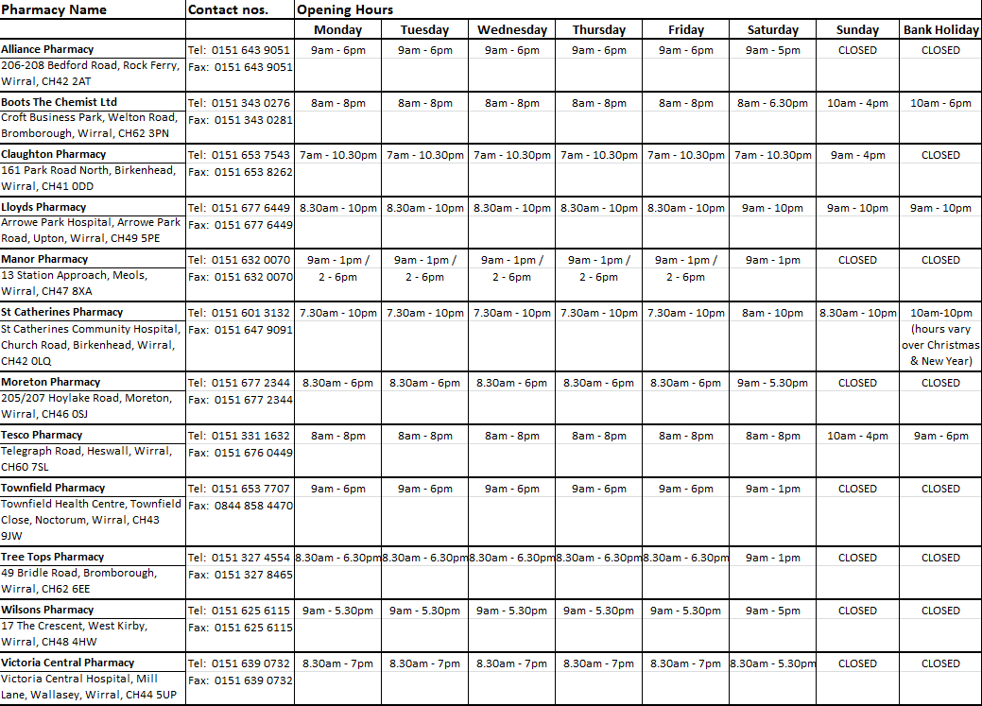
Appendix 2: Palliative Care Emergency Medicine Stock List

DRUG NAME | FORM and STRENGTH | MINIMUM QUANTITY
Alfentanil | Injection 5mg/ml ampoules x 5 | 2
 | Injection 1mg/2ml ampoules x 5 | 2
Cyclizine | Injection 50mg/ml x 10 ampoules | 1
Dexamethasone | Injection 3.3mg/1ml x 10 ampoules | 1
Fentanyl (Wirral brand of choice is Matrifen®) | Transdermal Patch 12micrograms/hr x 5 | 1
 | Transdermal Patch 25micrograms/hr x 5 | 1
 | Transdermal Patch 50 micrograms /hr x 5 | 1
 | Transdermal Patch 75 micrograms/hr x 5 | 1
 | Transdermal Patch 100 micrograms/hr x 5 | 1
Glycopyrronium bromide | Injection 600micrograms/3ml x 10 ampoules | 1
 | Injection 200micrograms/1ml x 10 ampoules | 1
Haloperidol | Injection 5mg/ml x 10 ampoules | 1
Hyoscine butylbromide | Injection 20mg/ml x 10 ampoules | 3
Hyoscine hydrobromide | Injection 400 micrograms/ml x 10 ampoules | 1
Levomepromazine | Injection 25mg/ml x 10 ampoules | 1
 | Tablets 25mg x 84 | 1
Metoclopramide | Injection 10mg/2ml x 10 ampoules | 2
Midazolam | Injection 10mg/2ml x 10 ampoules | 2
Morphine sulfate | Injection 10mg/ml x 5 ampoules | 2
 | Injection 30mg/ml x 5 ampoules | 2
Morphine (Immediate release) | Liquid 10mg/5ml (100ml) | 3
Morphine (Immediate release) | Liquid 100mg/5ml (120ml) NB concentrated | 1
Morphine (modified release BD dosing). (Wirral brand of choice is Zomorph®) | Capsules 10mg, 30mg, 60mg, 100mg (x60) | 1 of each
MST® (BD dosing) | Tablets 5mg (x60) | 1
Octreotide | Injection 500micrograms/ml x 5 ampoules | 1
Ondansetron | Injection 8mg/4ml x 5 ampoules | 2
Oxycodone | Injection 10mg/ml x 5 ampoules | 2
 | Injection 20mg/2ml x 5 ampoules | 2
 | Injection 50mg/ml x 5 ampoules | 1
Oxycodone (Immediate release) | Liquid 5mg/5ml x 250ml | 1
 | Liquid 10mg/ml x 120ml NB concentrated | 1
Oxycodone (Modified release)  (Wirral brand of choice is Longtec®) | Tablets 5mg, 10mg, 20mg, 40mg, 80mg (x56) | 1 of each
Sodium chloride 0.9% | Injection 10ml x 10 ampoules | 3
Water for Injection | Injection 10ml x 10 ampoules | 1

Appendix 3: Expired Stock Claims form
Palliative Care Emergency Stock Service
Date Expired Stock Claim Form

Service Provider

Address

Expired stock to be listed below:

Drug | Form | Quantity

Claims should be submitted annually. Payment is made annually (at current drug tariff price) towards the end of each financial year. Submit claims by 1st February.
Send completed claims form to: Nina Rogerson, Senior Support Officer, Medicines Management (Wirral), Old Market House, Hamilton Street, Birkenhead, CH41 5AL
Tel: 0151 541 5390

Appendix 4: Annual Invoice and Self Declaration Form

Service Provider name | Confirms it has the full range of palliative care medicines in stock and conforms with the service specification
Requires payment of £200 for undertaking the service.  Invoice submitted. | Yes / No
Full Address and contact details

Service provider to continue to undertake service? | Yes (please sign agreement)
 | No (please sign. Notice of termination is 30 days (1 month)

Signed
Print
Position

A copy of the service specification and this agreement should be kept by the service provider and made available for reference by all staff.

A copy of this page to be returned to:

Nina Rogerson, Senior Support Officer, Medicines Management (Wirral), Old Market House, Hamilton Street, Birkenhead, CH41 5AL
Tel: 0151 541 5390

