Reporting

Smartcard Sponsor to complete

Sponsors can run reports on CIS to check the smartcards in their organisation.
These reports will be useful for auditing certain aspects of RA within your practice such as user audits and removing leavers.
If you require more complex reports such as details of each position combined with assigned users, please request via the CSU IT Servicedesk
NOTE: At the time of writing HSCIC are working on improving the range of reports available, so you may find additional reports to those in this document.

- Login to CIS (via https://portal.national.ncrs.nhs.uk)

- Select Report

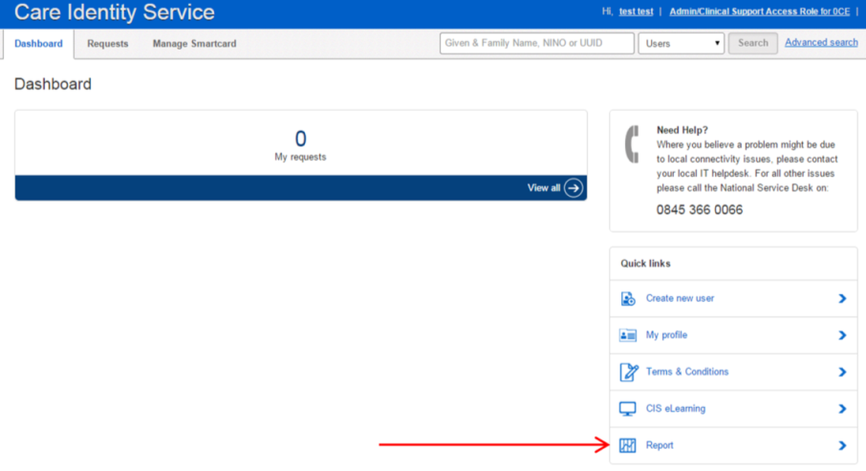

- Select the ‘Smartcards in Organisation’ report and select ‘Generate Report’

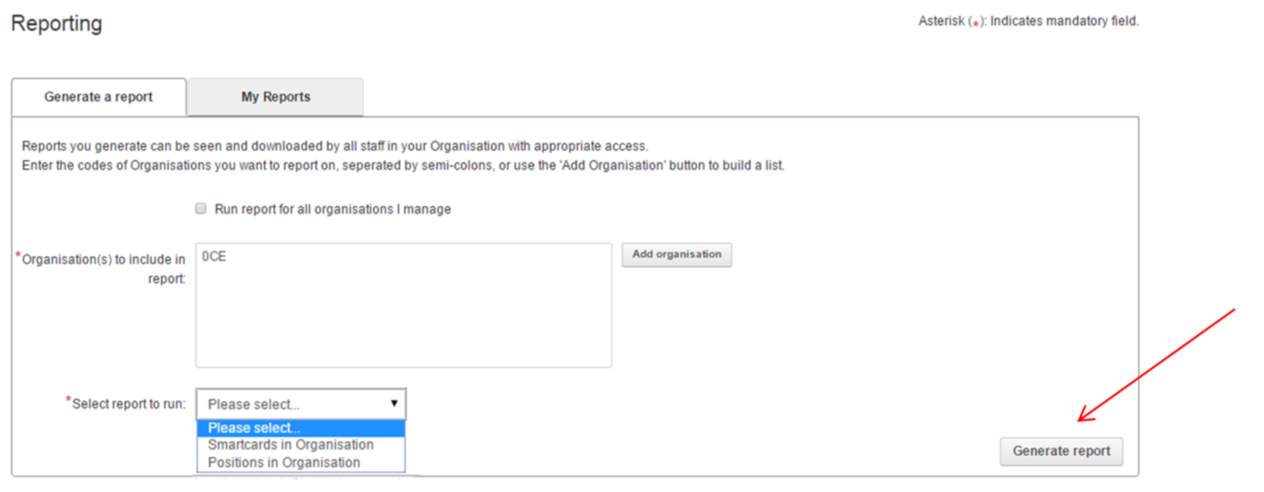

- Select the ‘My Reports’ Tab and ‘Download’ for the report that you have generated.
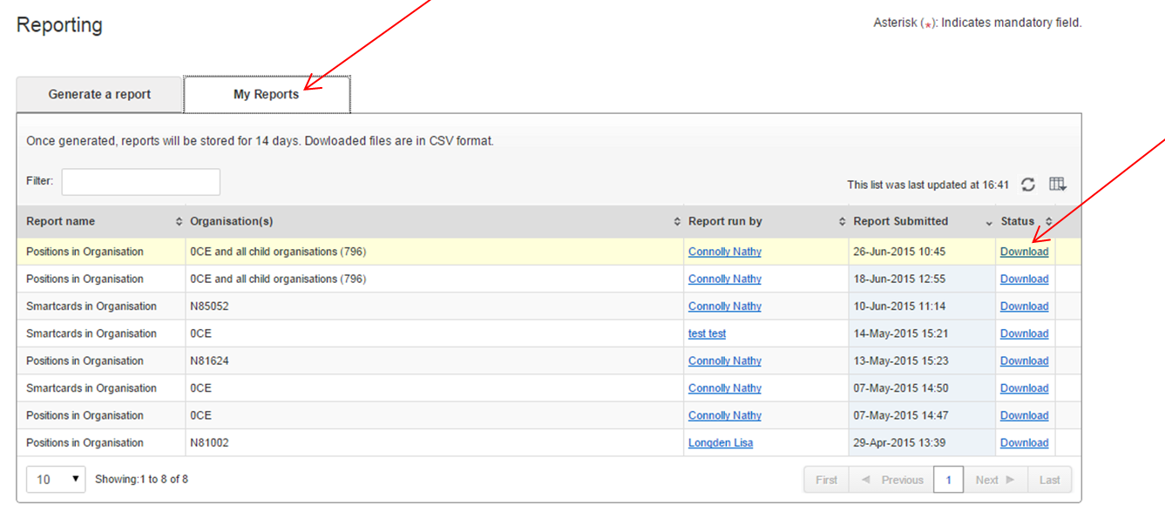
Your report will download as an MS Excel (.CSV) file. How this works will depend on your web browser and configuration.
Column E of the report will give you the names of those associated with your organisation.
Column I will identify those whose smartcard certificates are due to expire.
You are responsible for notifying the CSU IT servicedesk of any leavers.

